Microtask 1: Make an edit request and write about it.
Following is the process of editing page:
- Search any topic as your interest in google. And go to website.

- So, now make a new account in Wikipedia. You can find create account button in top right corner. Or you can simply Log in if you have already had an account. Note: you need account only if you want to publish your edit.
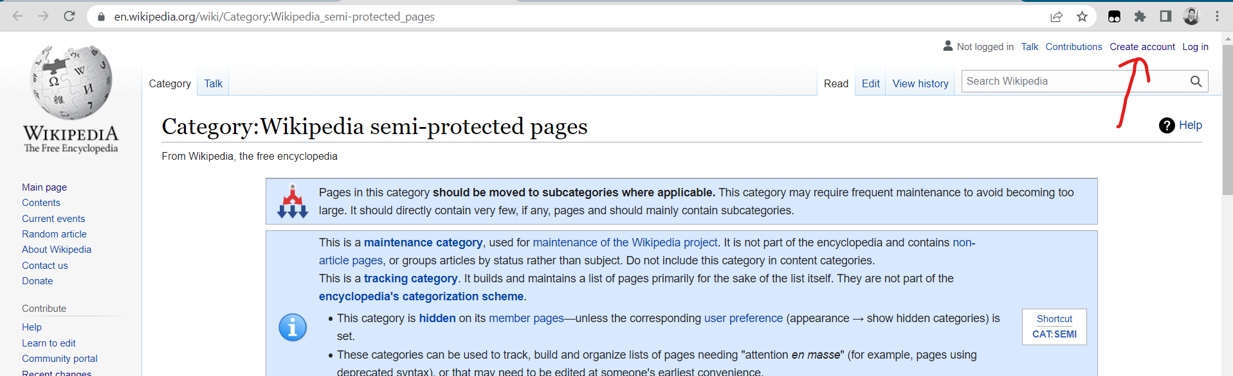

- Now you need to tap edit source button available in right side of navbar.

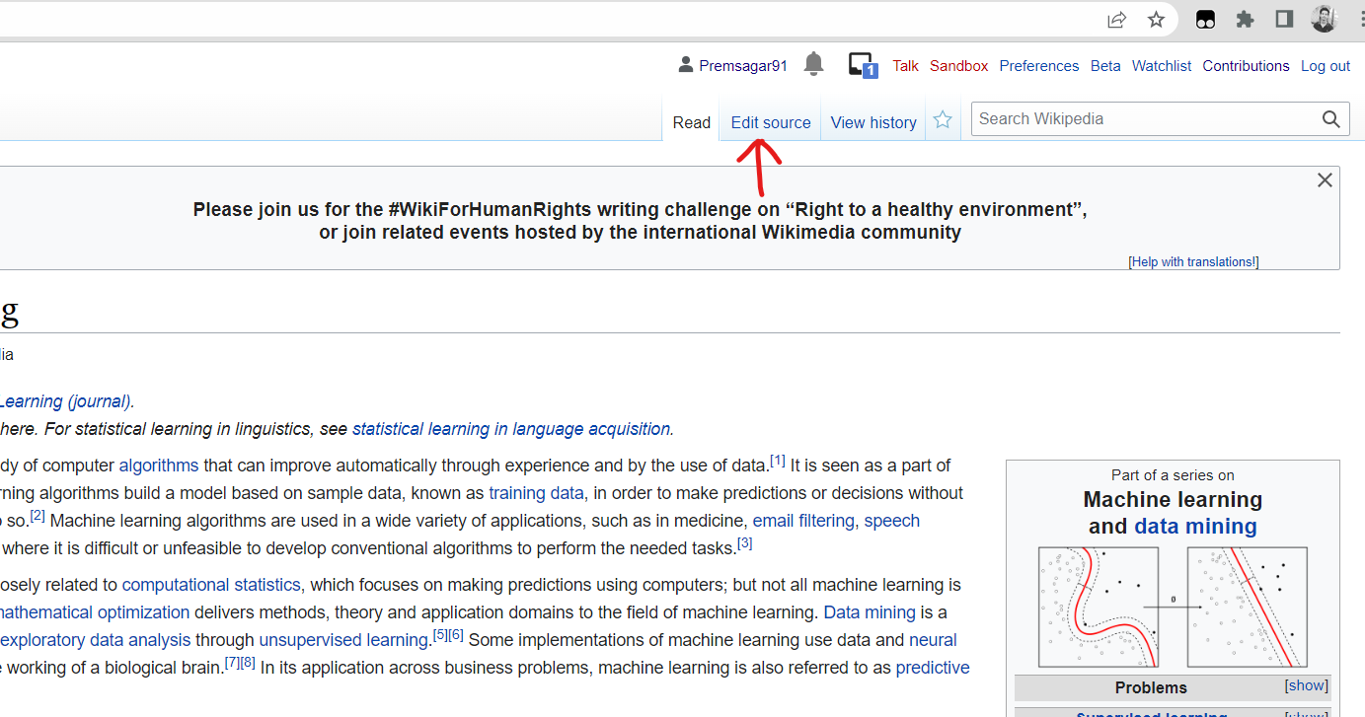
- Now you will see source editing page where you can edit the content. Basically, Wikipedia provide two ways to editing first one is source editing and another is visual editing.
- Source editing
You can change it to visual editing by tapping pencil button in right corner of editor.
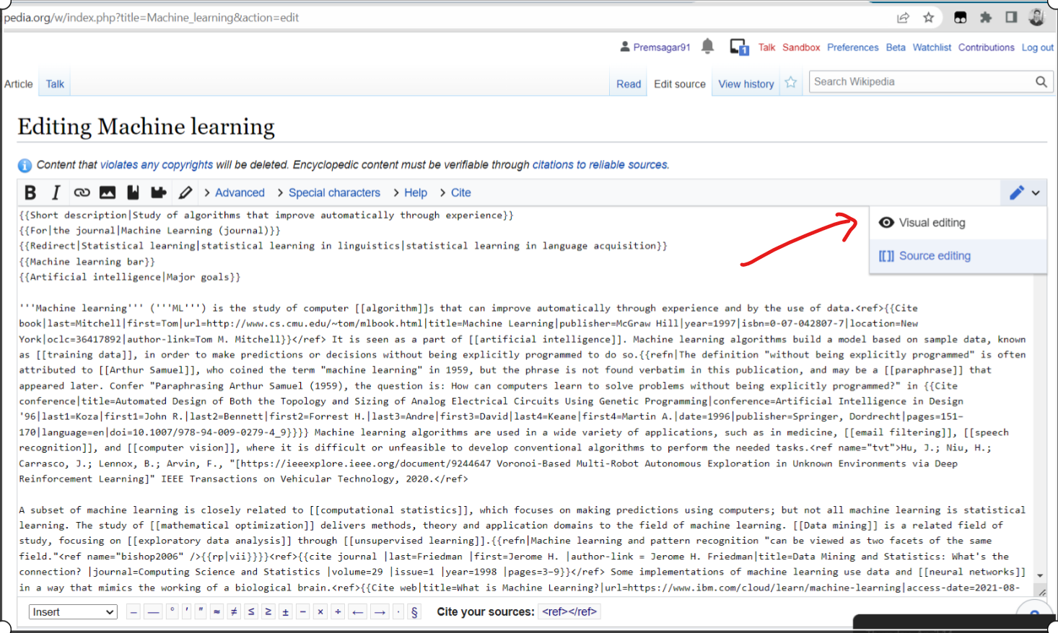

- Visual Editing
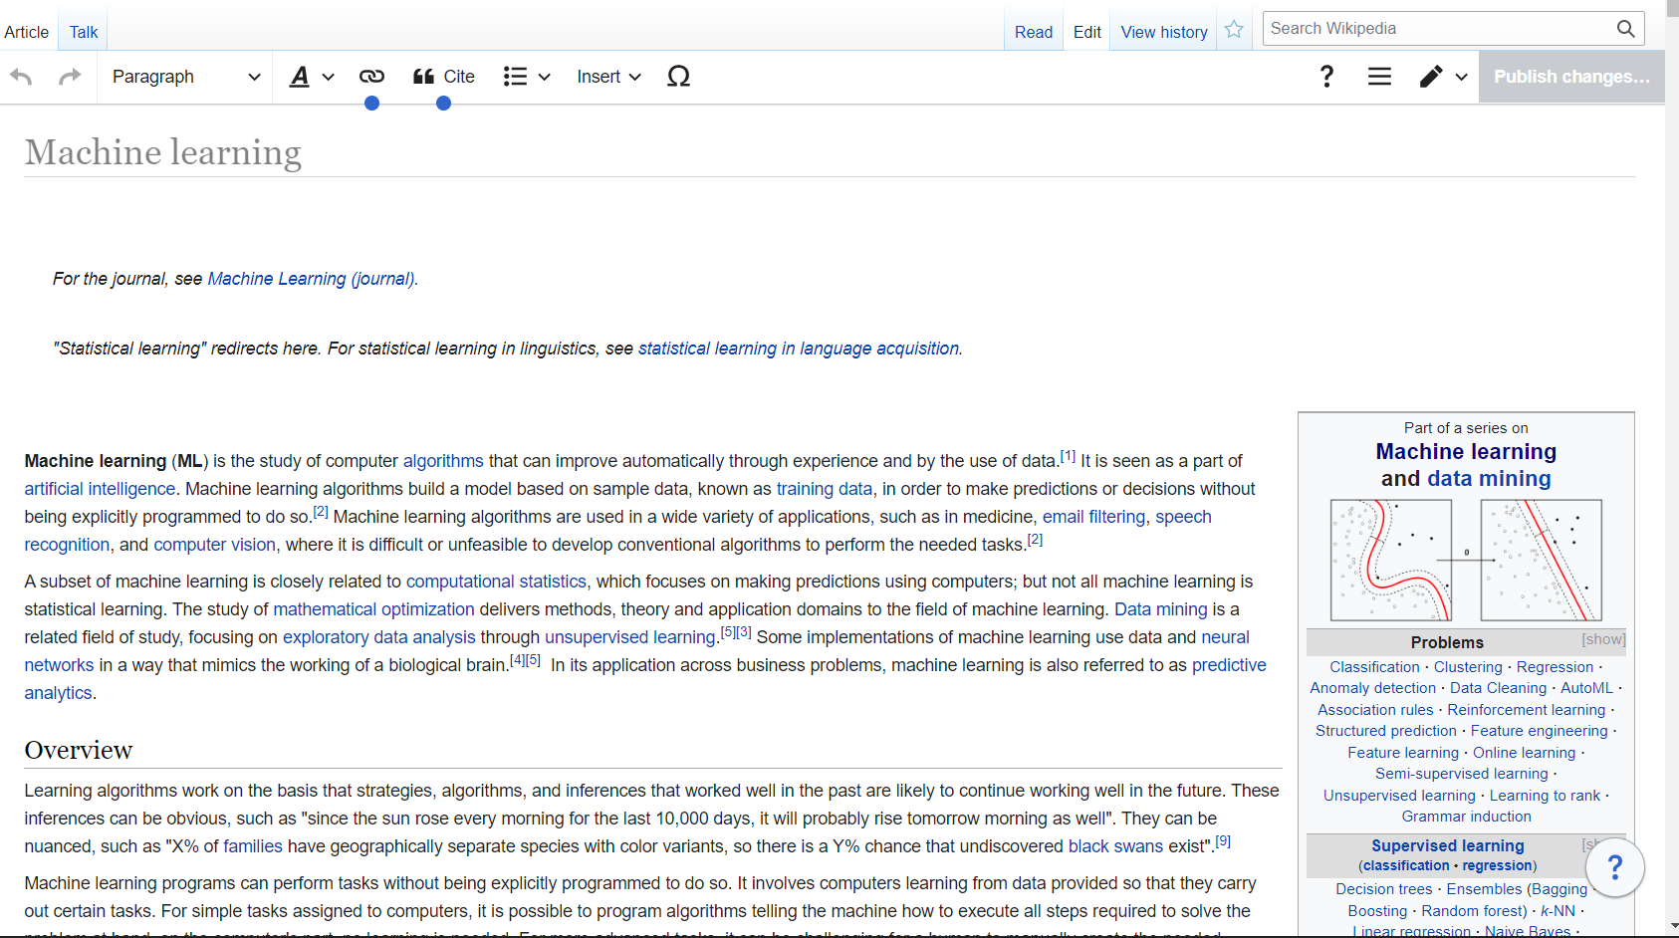
- Now, let’s make some change in article. After editing we need to press publish change button available in right corner.
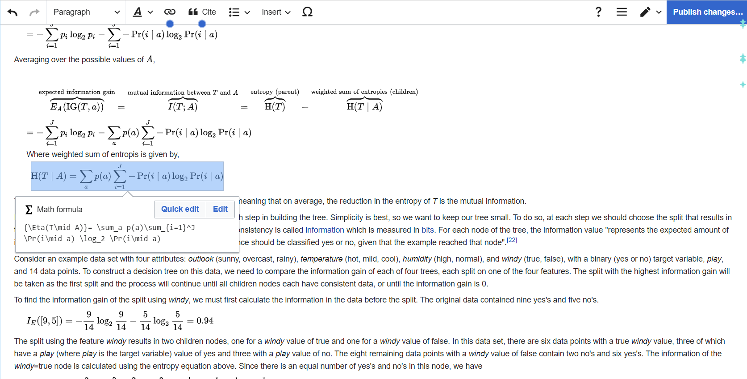
- Now pop-up window will appear here you need to describe your change.
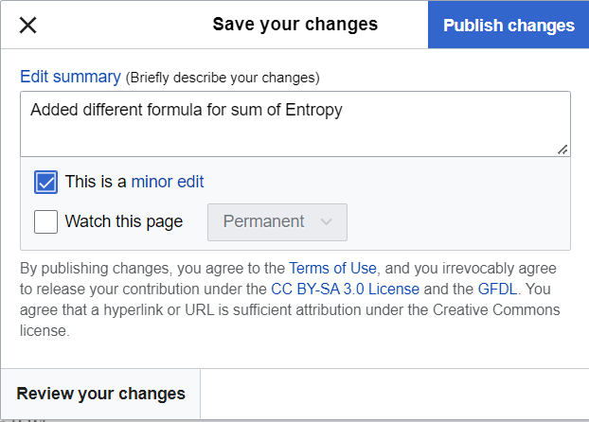
- Review your change and click publish.
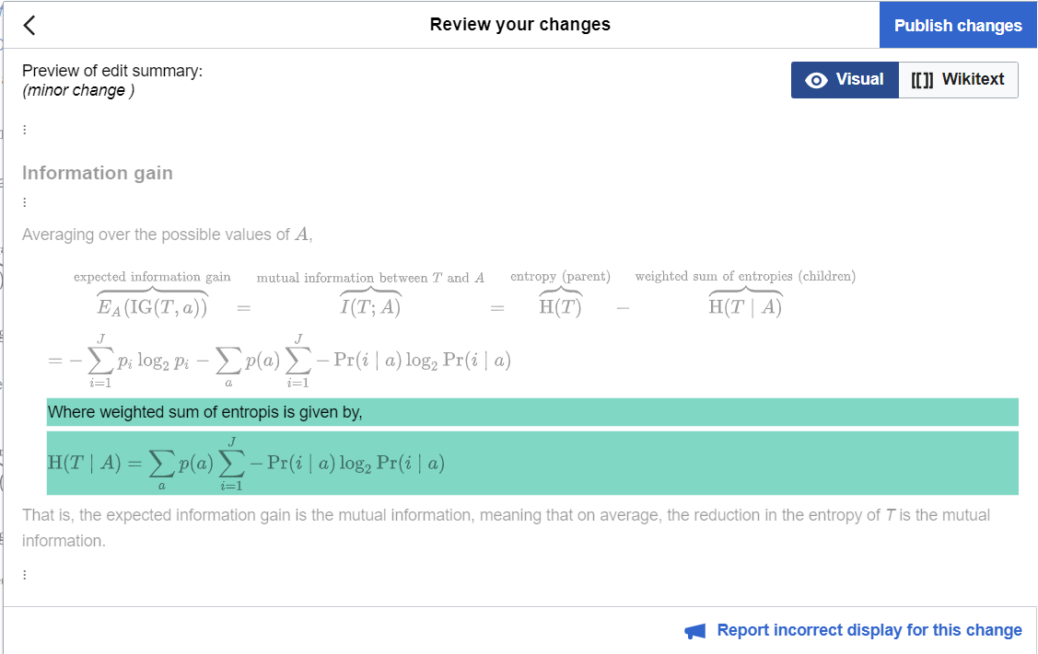
- My changes link: -

https://en.wikipedia.org/w/index.php?title=Decision_tree_learning&diff=prev&oldid=1082660125

and article link: -

https://en.wikipedia.org/wiki/Decision_tree_learning

- Some pages are protected and you can not edit directly but you can submit request for edit if your proposal is valid then they will make change on this.
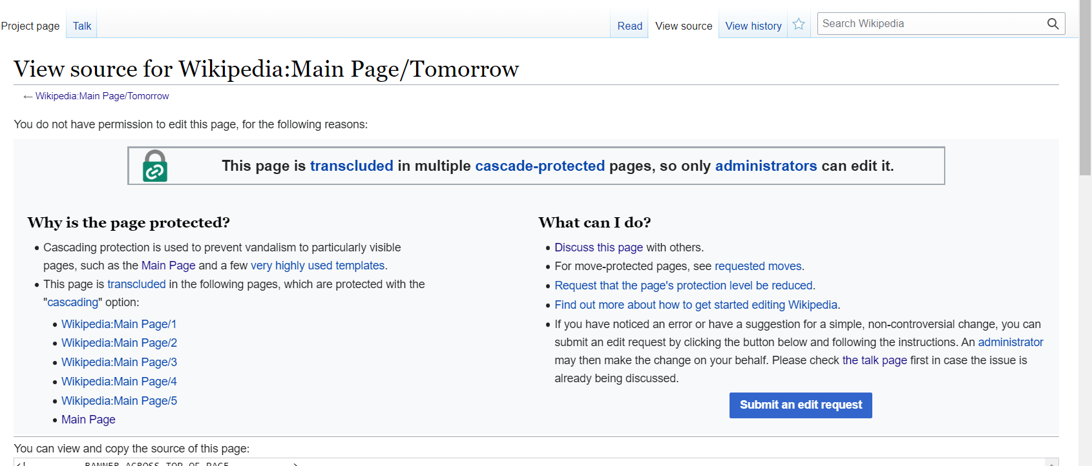

  - Before submitting request, you need to submit request in talk page.

