Communicate when pages are not supported in other languages in the current ULS

- When content is available in other languages (Above the fold). 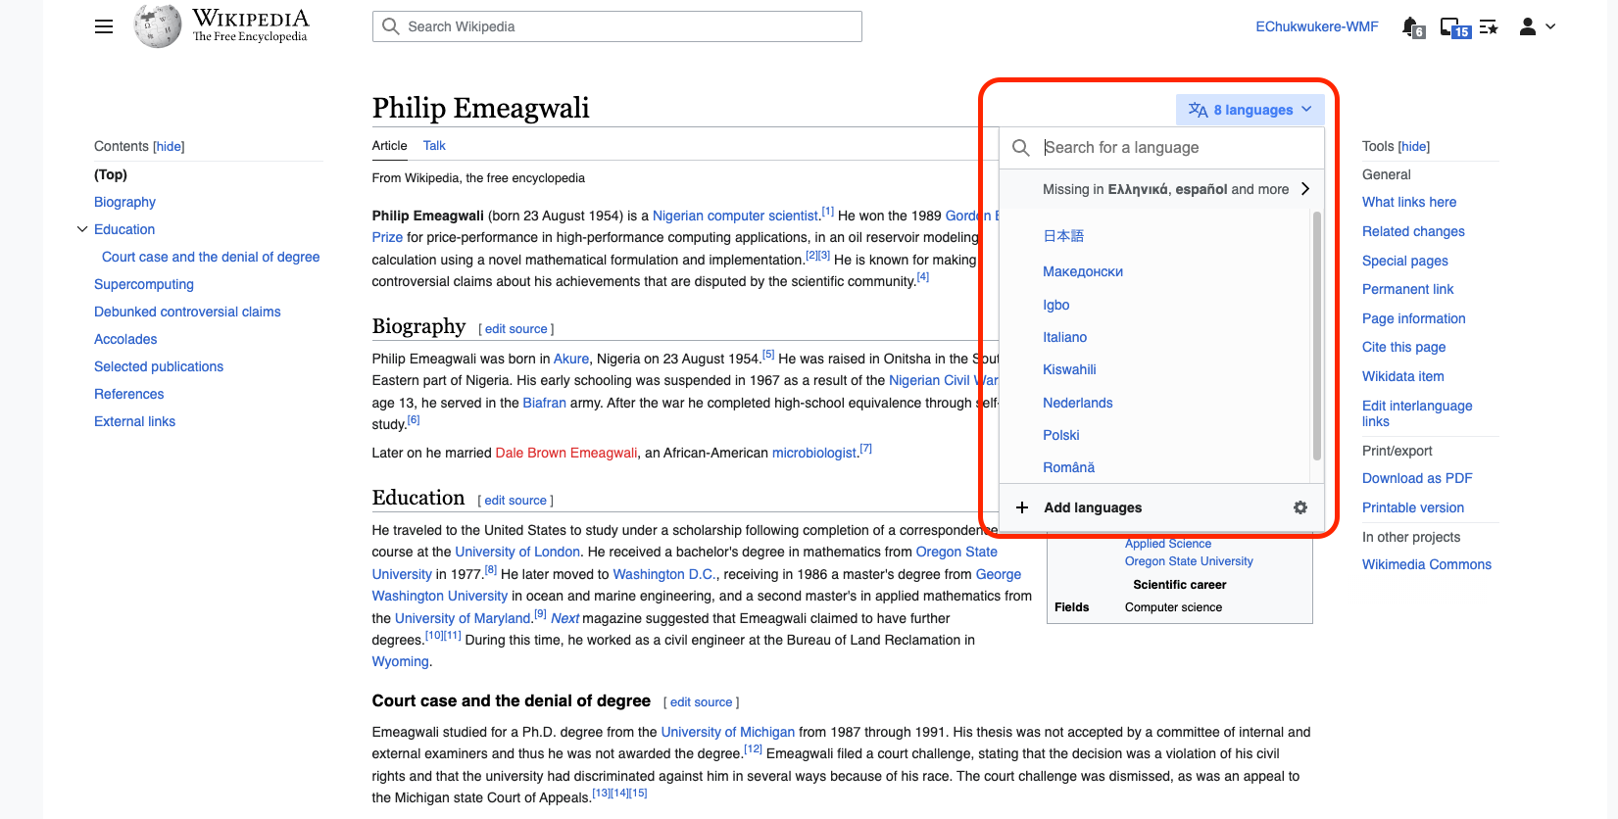

This shows the language icon highlighted in blue and shows links where the content is missing in other languages. Access to Add language and access to the settings icon.

- When content is available in other languages (Below the fold). 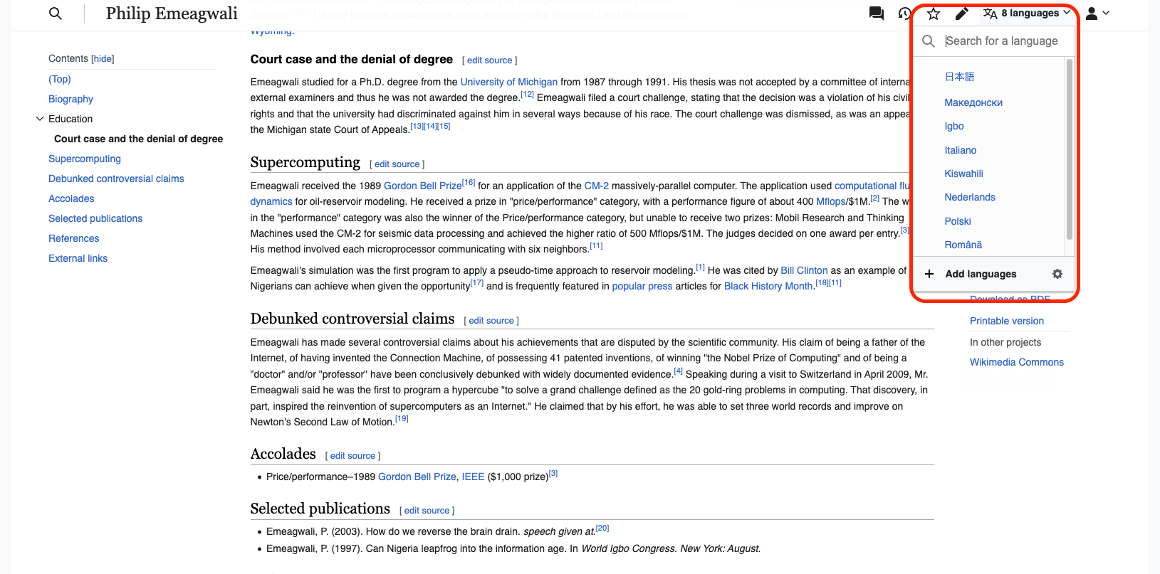

This shows the language icon is not highlighted in blue and shows links where the content is missing in other languages. Access to Add language and access to the settings icon.

- When content is not available in other languages (Above the fold). 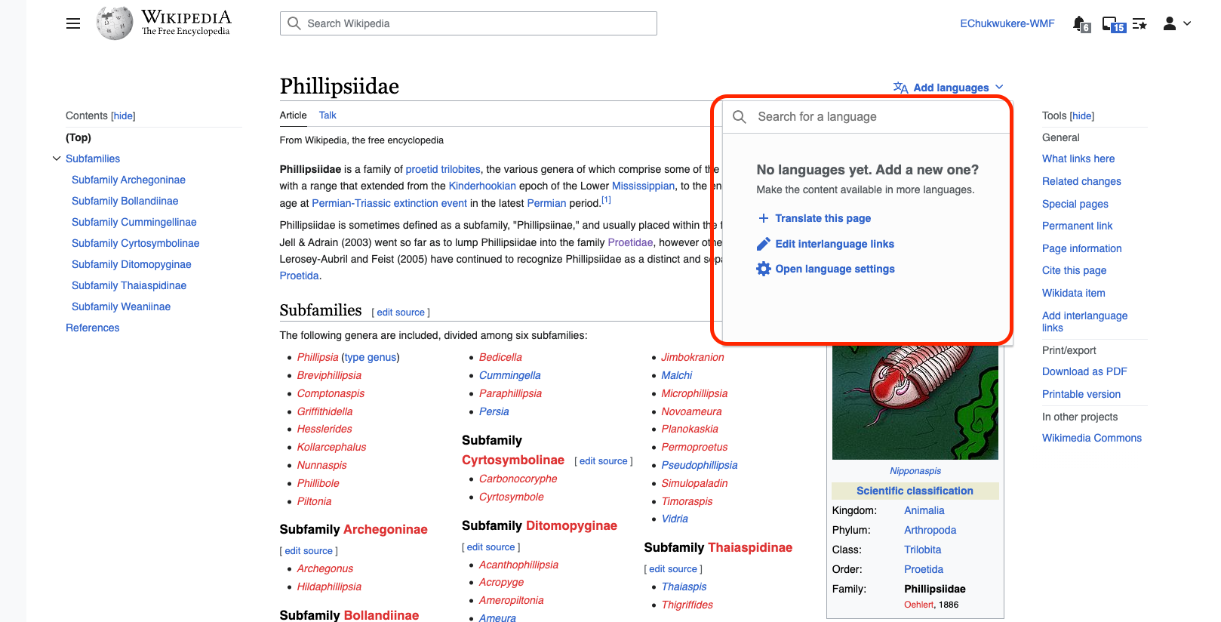

This shows the language icon is highlighted in blue and shows no language has been added yet. Shows links to “Translate the page”, “Edit Interlanguage links” and “Open Language settings.”

- When content is not available in other languages (Below the fold). 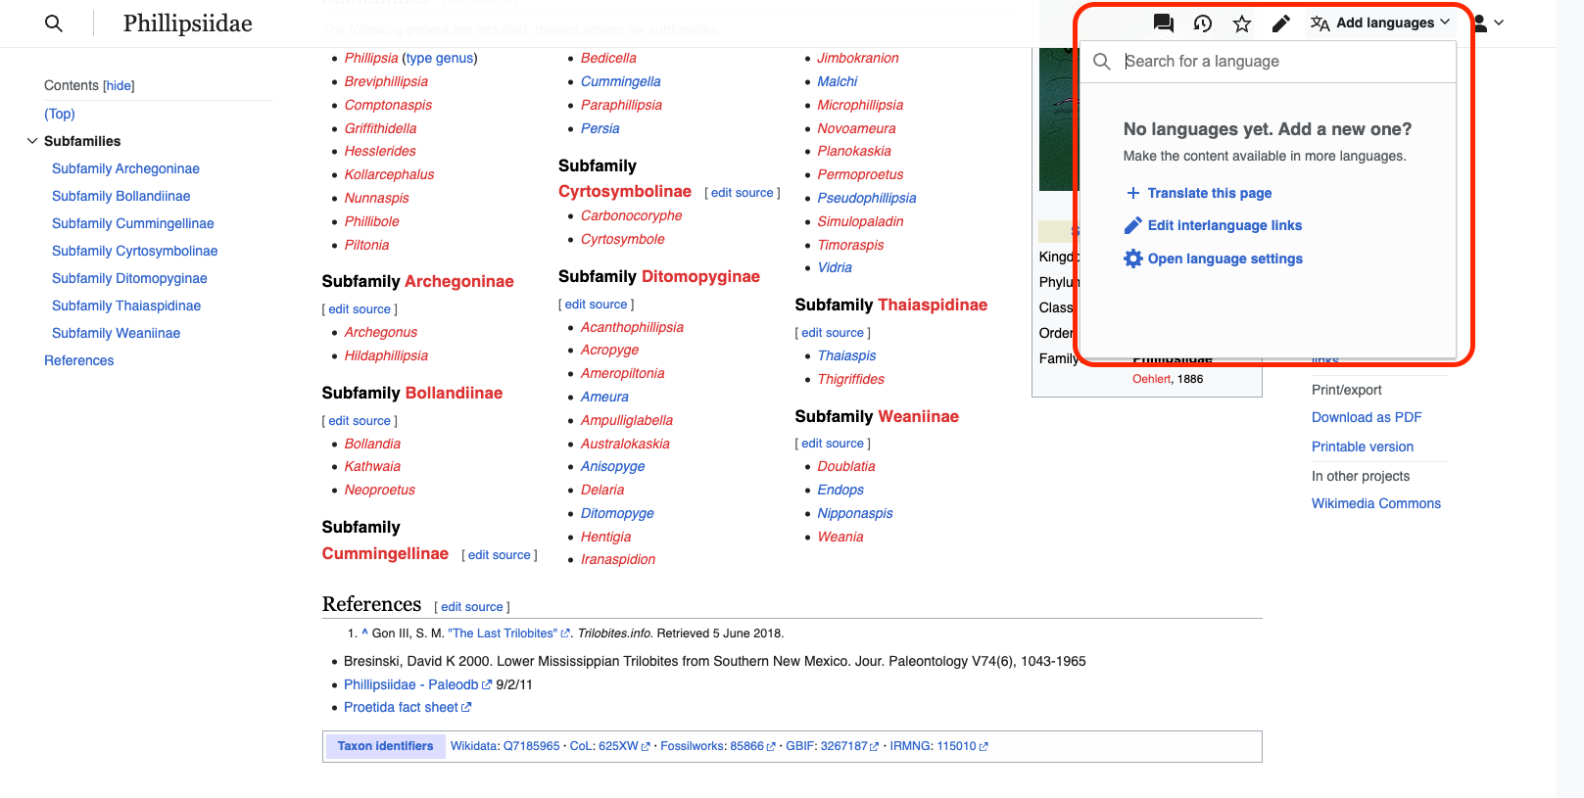
This shows the language icon is not highlighted in blue and shows no language has been added yet. Shows links to “Translate the page”, “Edit Interlanguage links” and “Open Language settings.”

- When Page content does not exist (Above the fold). 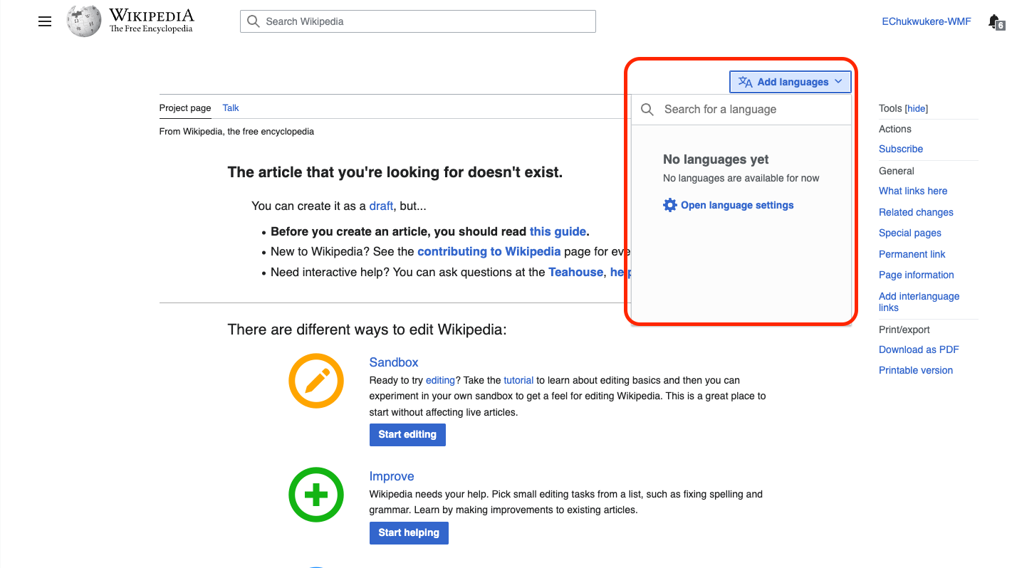

This shows the language icon is highlighted in blue and shows no language has been added yet. Shows links to “Open Language settings.”

- When Page content does not exist (Below the fold). 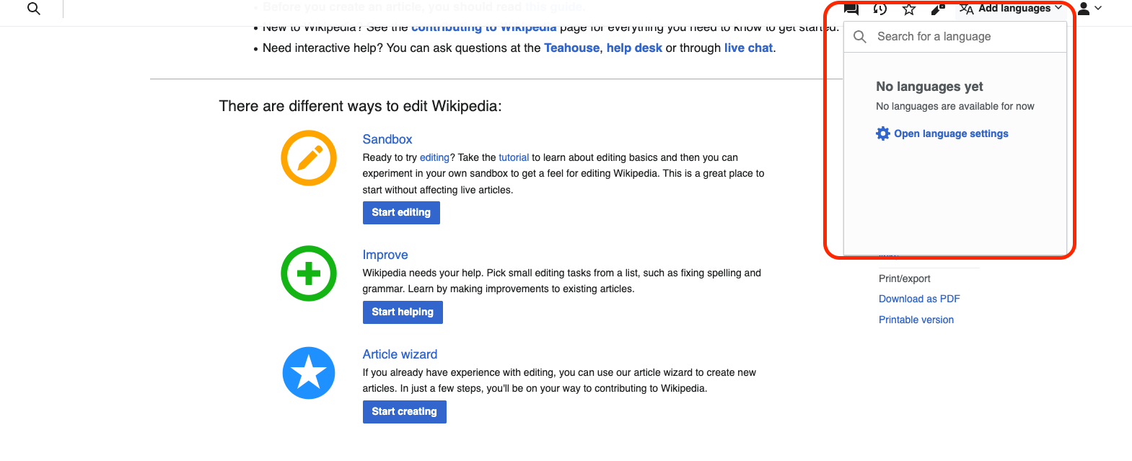
This shows the language icon is not highlighted in blue and shows no language has been added yet. Shows links to “Open Language settings.”

- Talk Pages (Above the fold) 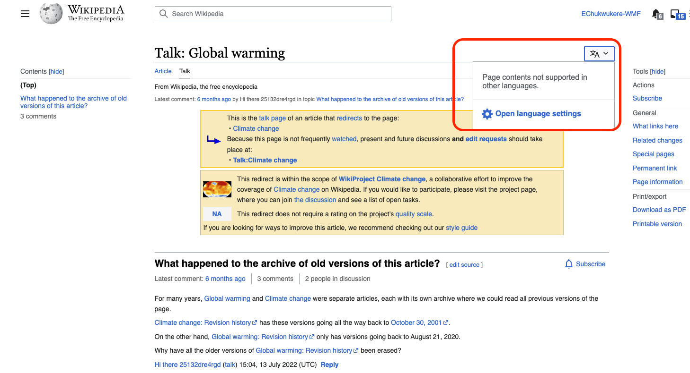

This shows the language icon is not highlighted in blue and shows Page contents not supported in other languages. Shows link to “Open Language settings.”

- Talk Pages (Below the fold) 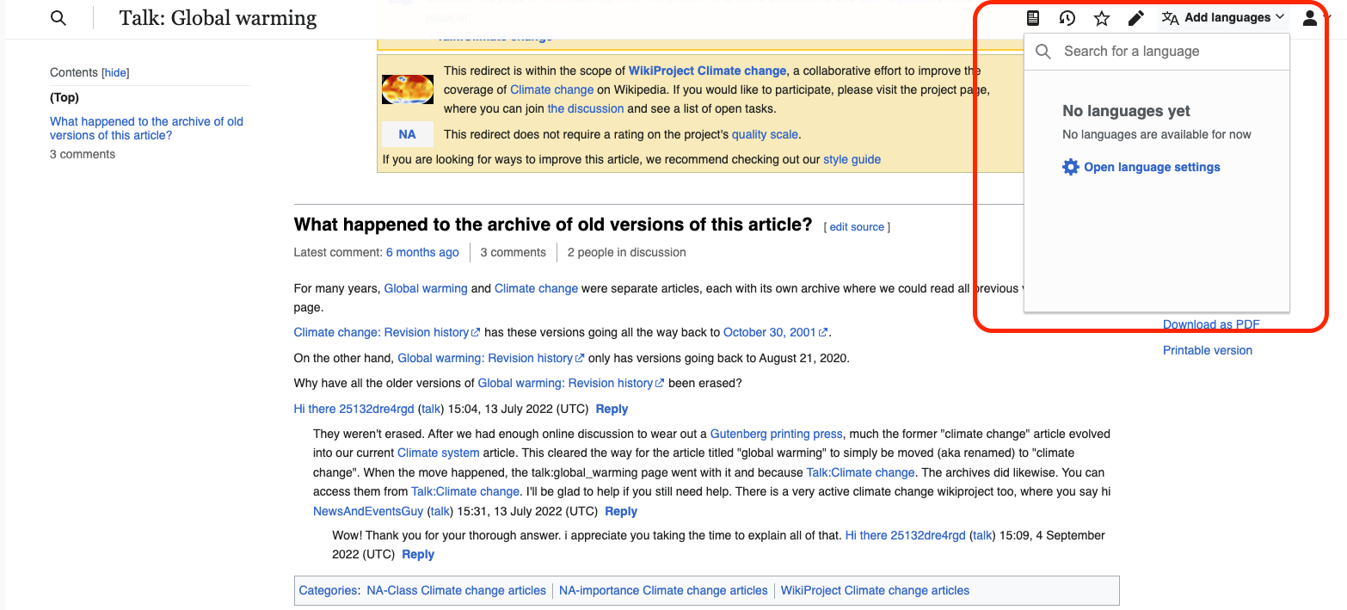

This shows the language icon is not highlighted in blue and shows No Languages yet. Shows link to “Open Language settings.”

- Template with Data ( Above the fold) 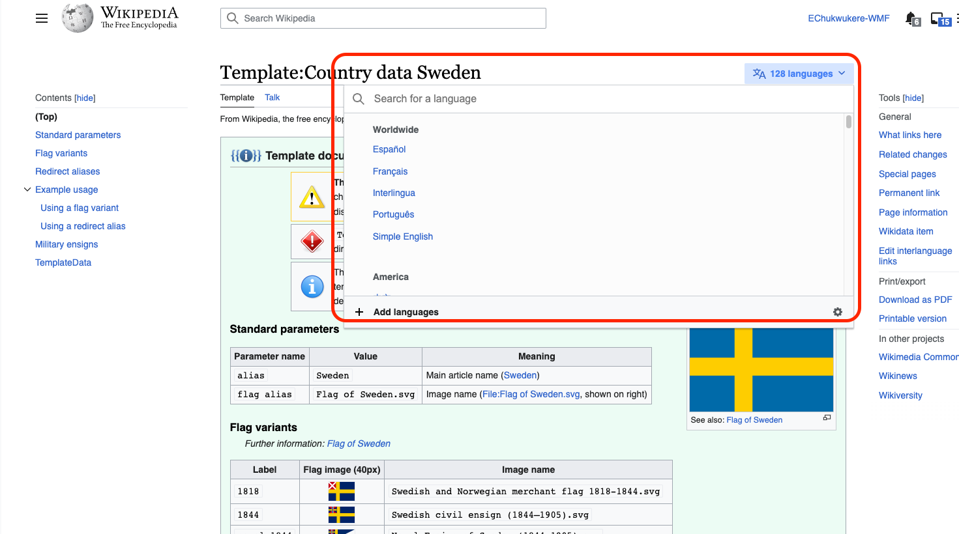

This shows the language icon highlighted in blue and does not show suggestion of suggested languages. Access to Add language and access to the settings icon.

- Template with Data ( Below the fold) 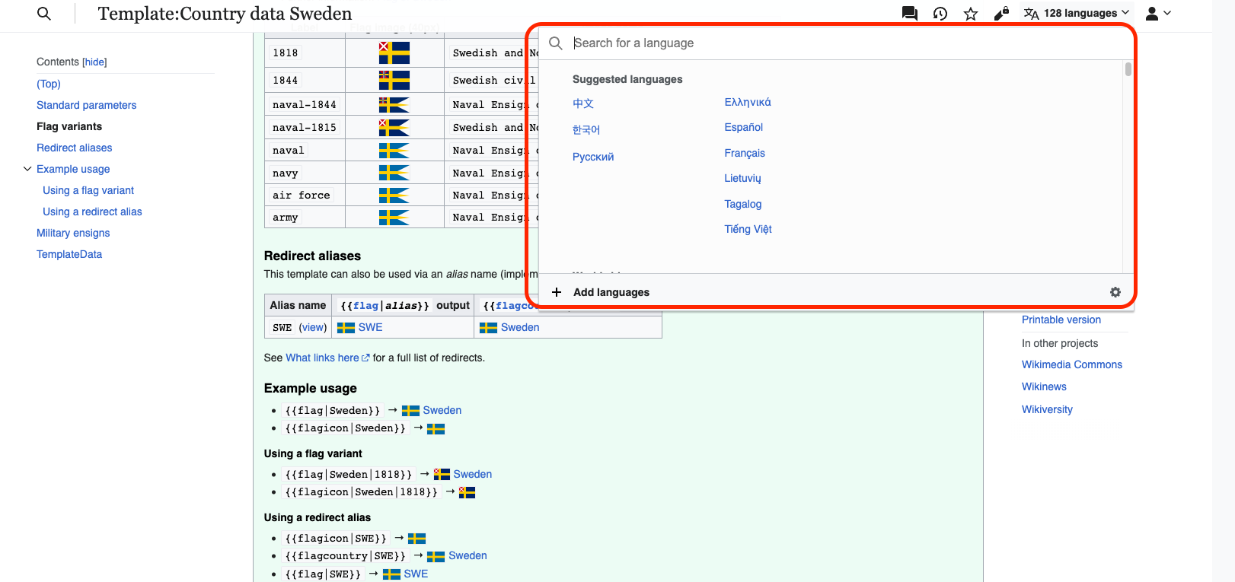

This shows the language icon is not highlighted in blue and show suggestion of suggested languages. Access to Add language and access to the settings icon. This is inconsistent with the Above the fold scenario

- Template without Data ( Above the fold) 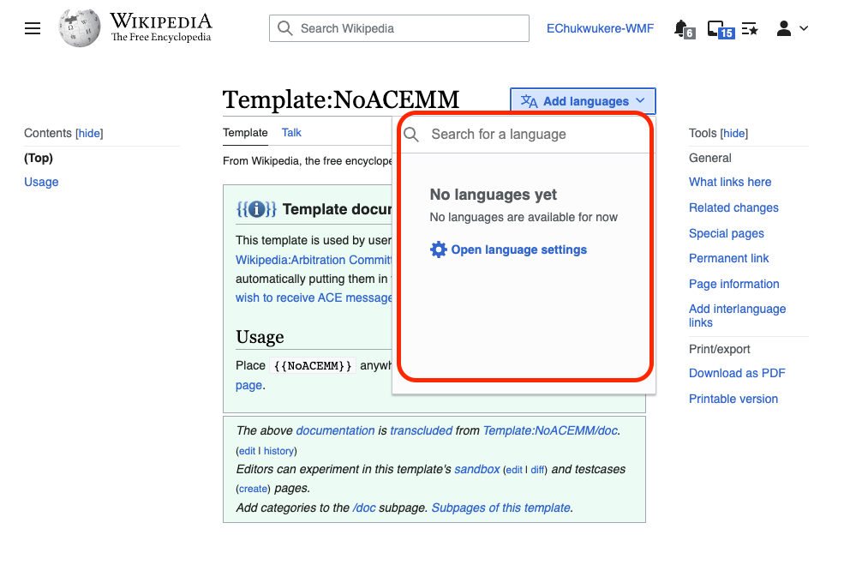
This shows the language icon is highlighted in blue and shows no language has been added yet. Shows link to “Open Language settings.”

- Template without Data ( Below the fold) 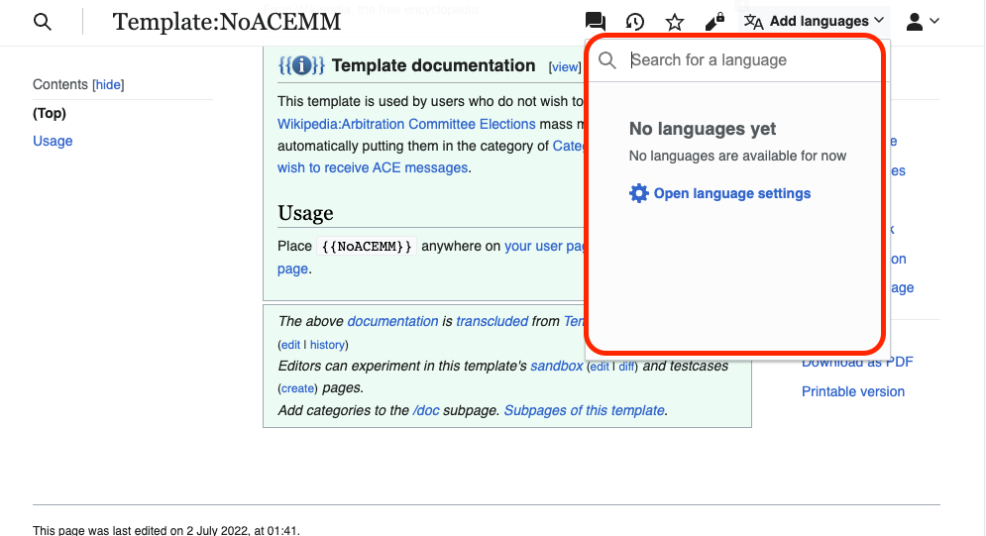
This shows the language icon is not highlighted in blue and shows no language has been added yet. Shows link to “Open Language settings.”

