MediaWiki 1.22.5 instalación

Build de prerrequisitos e instalación

tar xfz httpd-2.2.27.tar.gz
cd httpd-2.2.27
./configure --enable-so
make clean
make
make install

tar xfz php-5.3.28.tar.gz
cd php-5.3.28
./configure --enable-debug --with-apxs2=/usr/local/apache2/bin/apxs --with-oci8=/opt/oracle/product/oracle/11.1.0/db
make clean
make
make install

vi /usr/local/apache2/conf/httpd.conf
comprobar que está
LoadModule php5_module modules/libphp5.so

tar xfz /root/git-1.9.2.tar.gz
cd git-1.9.2
./configure
make clean
make
make install

rpm –ivh libwmf-0.2.8.4-10.1.i386.rpm ImageMagick-6.2.8.0-3.el5.4.i386.rpm

cd /usr/local/apache2/htdocs

modificar index.html

<html>
<meta http-equiv="refresh" content="0; http://altec291.altec.bsch/wiki/index.php"/>
</html>

Permisos de escritura para daemon:daemon

chown daemon:daemon cache images
chmod 775 cache images

tar xfz /root/mediawiki-1.22.5.tar.gz
mv mediawiki-1.22.5 wiki
cd wiki
ln -s . Article # directorio Article no existe

Oracle Setup

CREATE TABLESPACE TSD_D_WIKI
DATAFILE '/opt/oracle/oradata/wiki/tsd_d_wiki.dbf'
SIZE 200M REUSE LOGGING EXTENT MANAGEMENT LOCAL
SEGMENT SPACE MANAGEMENT AUTO
;
drop user wiki cascade;
commit;
CREATE USER wiki PROFILE DEFAULT IDENTIFIED BY wiki
DEFAULT TABLESPACE TSD_D_WIKI
TEMPORARY TABLESPACE TEMP
QUOTA UNLIMITED ON TSD_D_WIKI
ACCOUNT UNLOCK;
GRANT CREATE VIEW TO wiki;
GRANT CREATE SESSION TO wiki;
GRANT CREATE CLUSTER TO wiki;
GRANT UNLIMITED TABLESPACE TO wiki;
GRANT CONNECT TO wiki;
GRANT RESOURCE TO wiki;
grant alter session to wiki;
grant ctxapp to wiki;
grant execute on ctx_ddl to wiki;
grant create view to wiki;
grant create synonym to wiki;
grant create table to wiki;
grant create sequence to wiki;
grant create trigger to wiki;
commit;

alter trigger system.ALTER_OBJECT disable;

Oracle Text setup

connect / as SYSDBA
spool ctxsys_installation.log

-- Parameters are password, default t/s, temp t/s, don't lock the account.
@?/ctx/admin/catctx.sql secret SYSAUX TEMP NOLOCK

connect CTXSYS/secret
@?/ctx/admin/defaults/dr0defin.sql "ENGLISH";

connect / as SYSDBA
alter user ctxsys account lock password expire;

spool off

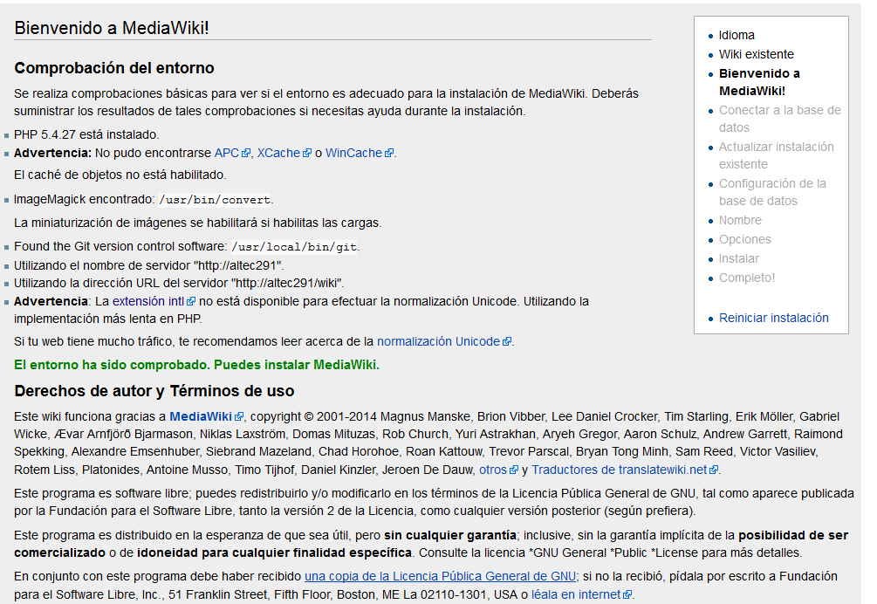

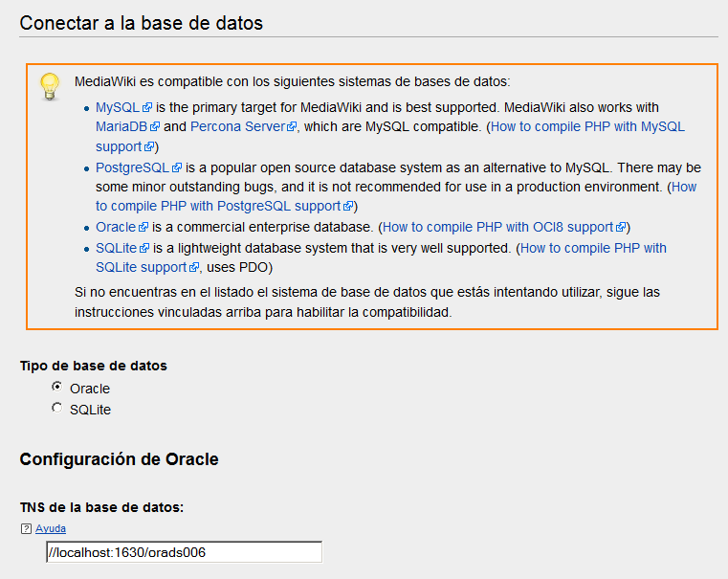

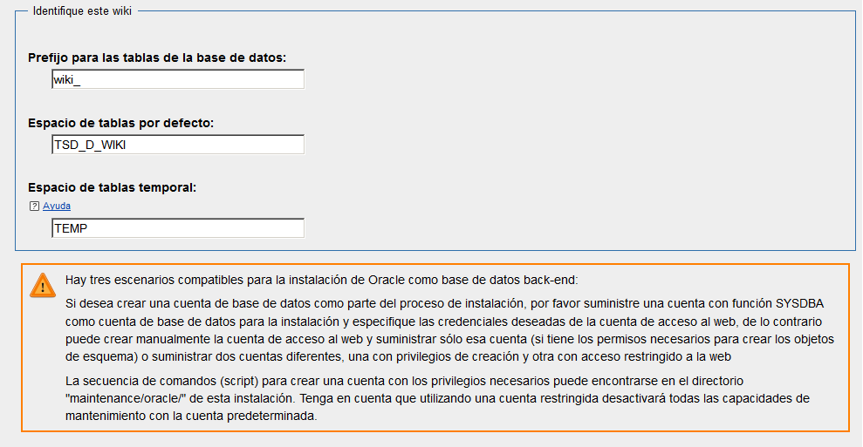

wiki/wiki
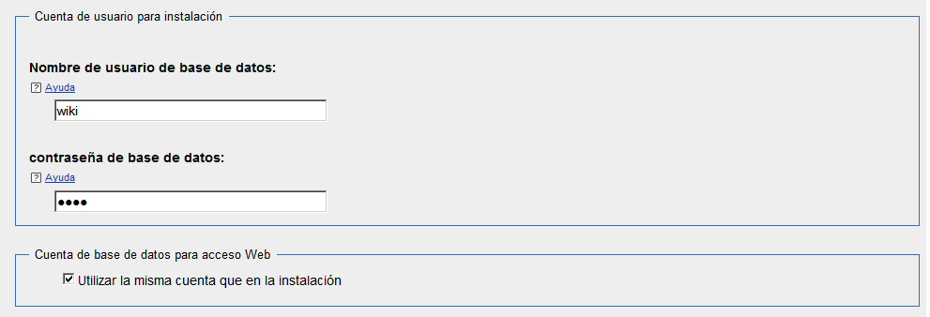

admin/Isban2014

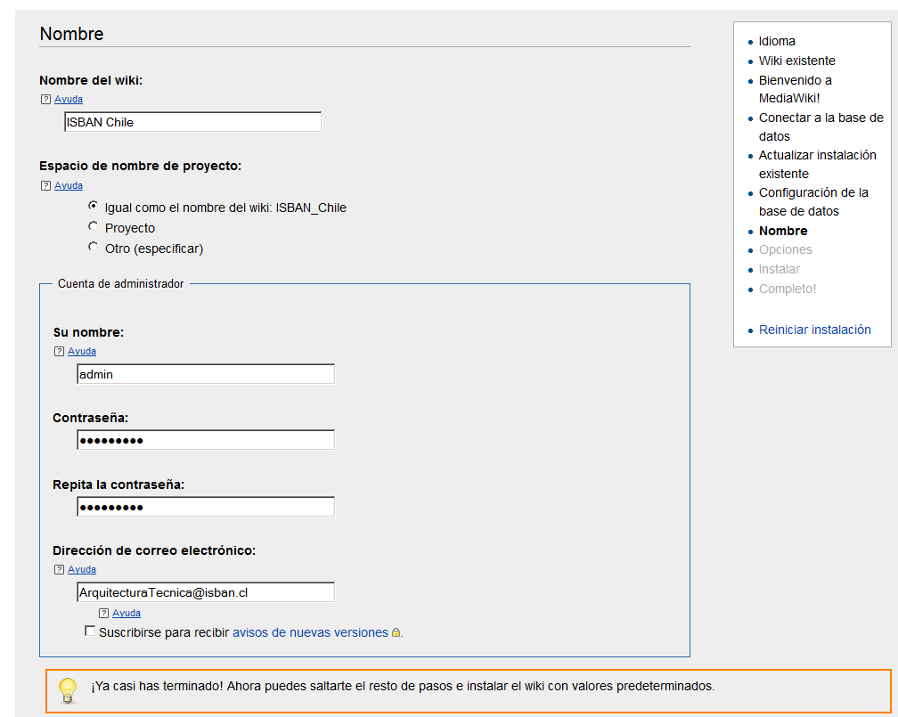

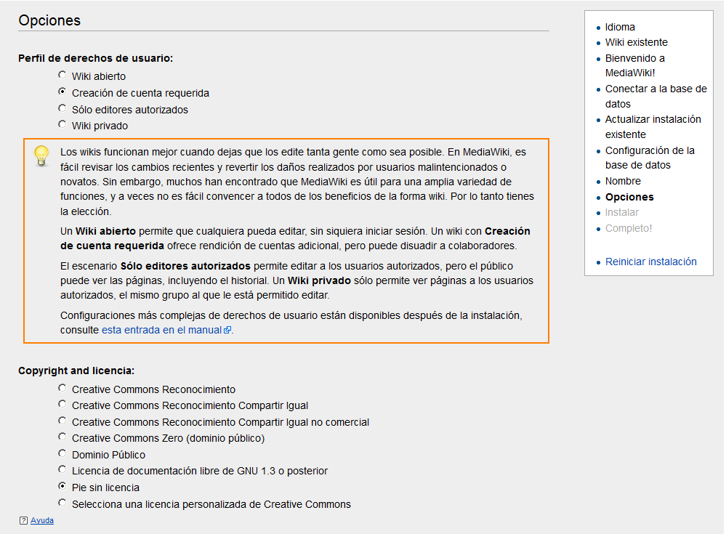

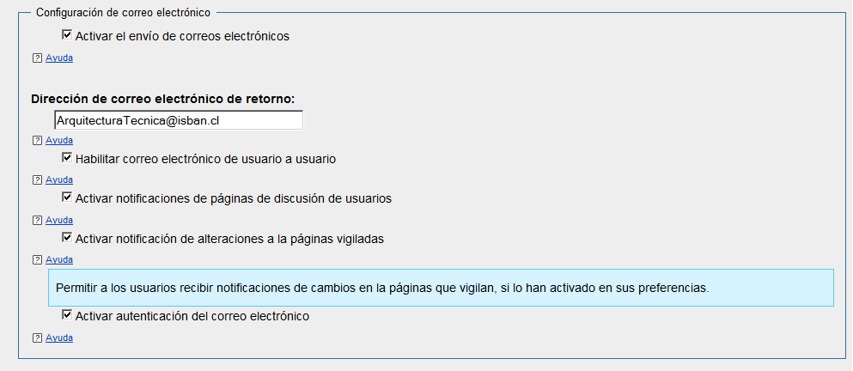

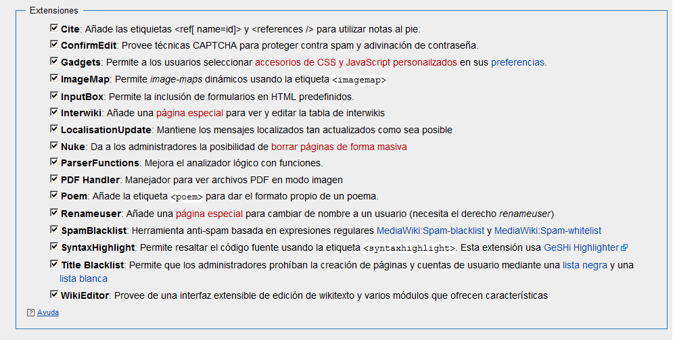

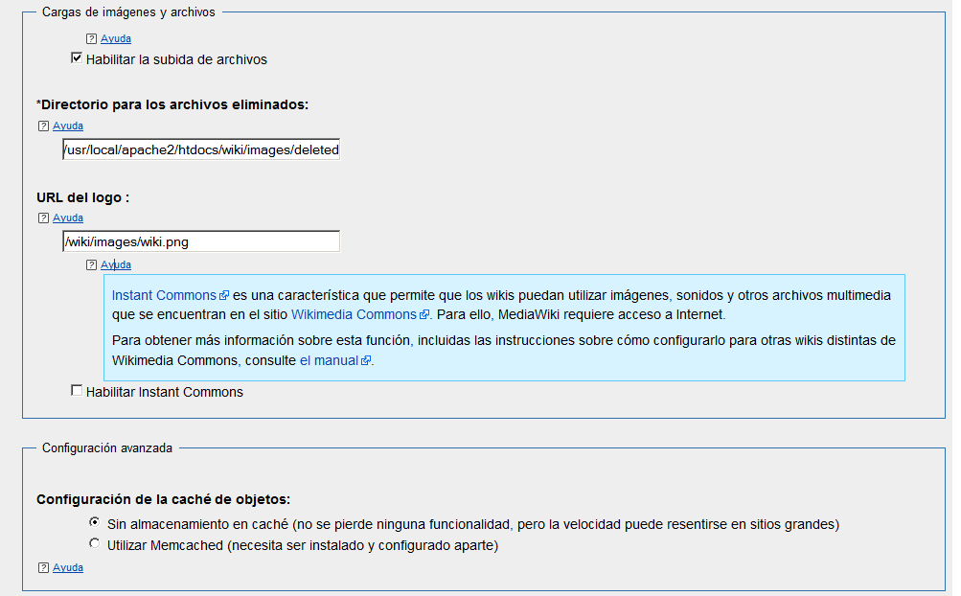

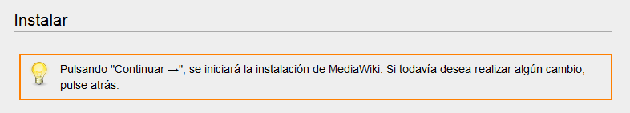

Error

- Extensiones inclusive... hecho
- Configurando la base de datos... hecho
- Creando el usuario de la base de datos... hecho
- Creando tablas... hecho
- Llenando la tabla interwiki predeterminada...
Se ha producido un error en la base de datos. Esto puede indicar un bug en el software.
  - Consulta:
INSERT INTO /*Q*/WIKI_INTERWIKI (iw_prefix,iw_url,iw_local,iw_api,iw_wikiid) VALUES (:iw_prefix, :iw_url, :iw_local, NULL, NULL)
  - Función: DatabaseOracle::insertOneRow
  - Error: 1400 ORA-01400: cannot insert NULL into ("WIKI"."WIKI_INTERWIKI"."IW_API")
Backtrace:
#0 /usr/local/apache2/htdocs/wiki/includes/db/DatabaseOracle.php(620): DatabaseOracle->reportQueryError('ORA-01400: cann...', 1400, 'INSERT INTO /*Q...', 'DatabaseOracle:...')
#1 /usr/local/apache2/htdocs/wiki/includes/db/DatabaseOracle.php(493): DatabaseOracle->insertOneRow('interwiki', Array, 'DatabaseInstall...')
#2 /usr/local/apache2/htdocs/wiki/includes/installer/DatabaseInstaller.php(633): DatabaseOracle->insert('interwiki', Array, 'DatabaseInstall...')
#3 [internal function]: DatabaseInstaller->populateInterwikiTable(Object(OracleInstaller))
#4 /usr/local/apache2/htdocs/wiki/includes/installer/Installer.php(1589): call_user_func(Array, Object(OracleInstaller))
#5 /usr/local/apache2/htdocs/wiki/includes/installer/WebInstallerPage.php(1254): Installer->performInstallation(Array, Array)
#6 /usr/local/apache2/htdocs/wiki/includes/installer/WebInstaller.php(275): WebInstaller_Install->execute()
#7 /usr/local/apache2/htdocs/wiki/mw-config/index.php(61): WebInstaller->execute(Array)
#8 /usr/local/apache2/htdocs/wiki/mw-config/index.php(29): wfInstallerMain()
#9 {main}

SQL> connect wiki/wiki
Connected.
SQL> desc WIKI_INTERWIKI ;
Name Null? Type
----------------------------------------- -------- ----------------------------
IW_PREFIX NOT NULL VARCHAR2(32)
IW_URL NOT NULL VARCHAR2(127)
IW_API NOT NULL BLOB
IW_WIKIID VARCHAR2(64)
IW_LOCAL NOT NULL CHAR(1)
IW_TRANS NOT NULL CHAR(1)

SQL> select * from WIKI_INTERWIKI ;

no rows selected

Varios errores en strpos()

Warning: strpos() expects parameter 1 to be string, object given in /usr/local/apache2/htdocs/wiki/includes/db/DatabaseOracle.php on line

Correcciones

/usr/local/apache2/htdocs/wiki/maintenance/oracle/tables.sql

Se permiten NULLS en las 3 columnas

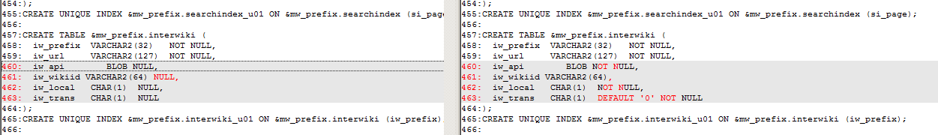

/usr/local/apache2/htdocs/wiki/includes/db/DatabaseOracle.php

Cuando el parámetro no es un string (objeto blob), no se verifica ni elimina el string “/*Q*/”

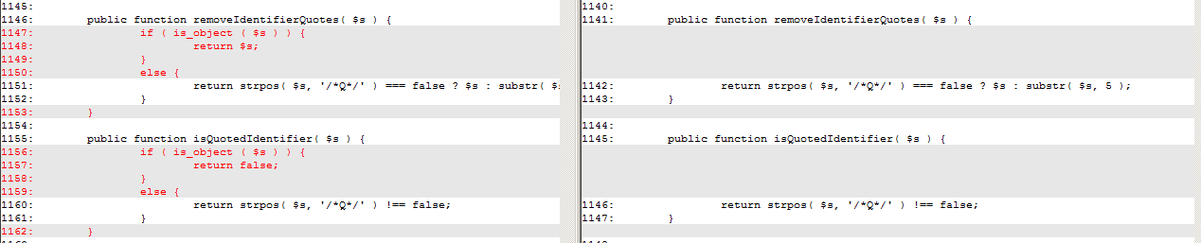

Después de corregir pasa OK

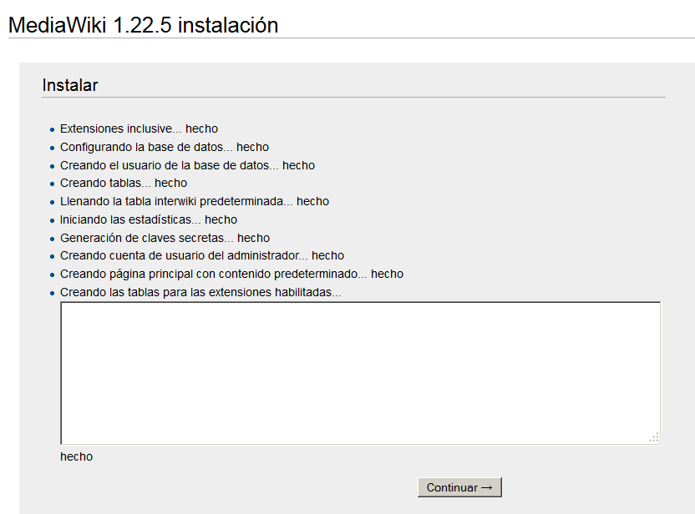

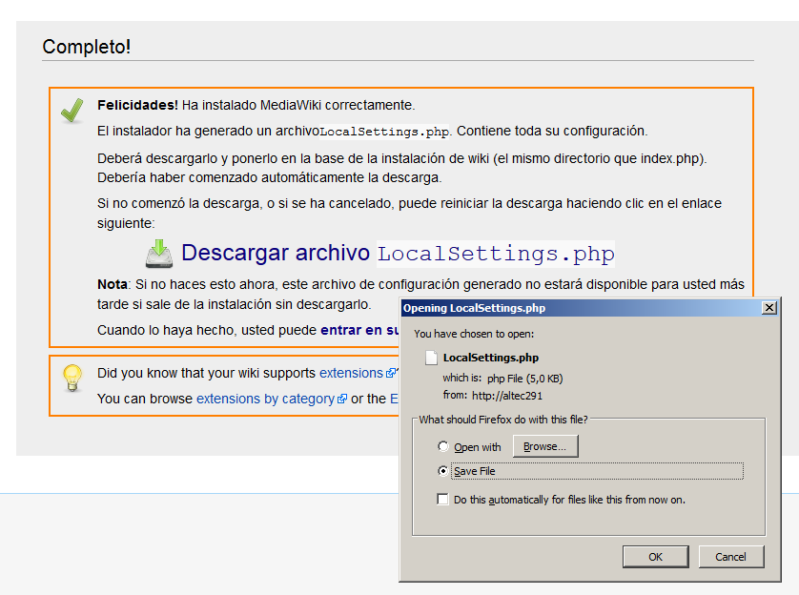

Cambios a LocalSettings.php

$wgCacheDirectory = "$IP/cache";
$wgShowExceptionDetails = true;

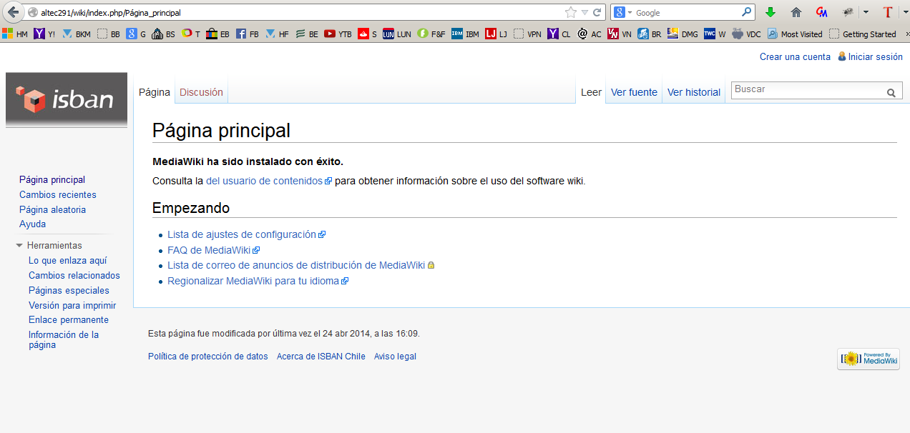

Preparación de startup automático

Se adapta el script /etc/init.d/httpd estándar

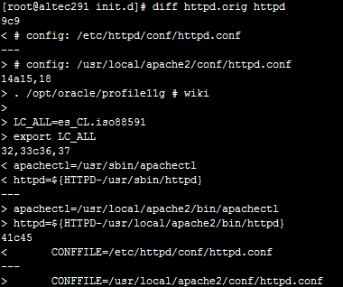

chkconfig --level 235 httpd on

Report opened in Support Desk

http://www.mediawiki.org/w/index.php?title=Project:Support_desk&limit=20#problems_with_oci8_using_Oracle_11g__42506

problems with oci8 using Oracle 11g
- History
- Summarize
- Change subject
Collapse
I have many problems related to BLOB data type: /usr/local/apache2/htdocs/wiki/includes/db/DatabaseOracle.php(1146) : Warning - strpos() expects parameter 1 to be string, object given /usr/local/apache2/htdocs/wiki/includes/db/DatabaseOracle.php(1142) : Warning - strpos() expects parameter 1 to be string, object given /usr/local/apache2/htdocs/wiki/includes/db/DatabaseOracle.php(1142) : Warning - substr() expects parameter 1 to be string, object given I fixed these errors with this code:
public function removeIdentifierQuotes( $s ) {
if ( is_object ( $s ) ) {
return $s;
}
else {
return strpos( $s, '/*Q*/' ) === false ? $s : substr( $s, 5 );
}
}
public function isQuotedIdentifier( $s ) {
if ( is_object ( $s ) ) {
return false;
}
else {
return strpos( $s, '/*Q*/' ) !== false;
}
}
Another error during config was: INSERT INTO /*Q*/WIKI_INTERWIKI (iw_prefix,iw_url,iw_local,iw_api,iw_wikiid) VALUES (:iw_prefix, :iw_url, :iw_local, NULL, NULL) Error: 1400 ORA-01400: cannot insert NULL into ("WIKI"."WIKI_INTERWIKI"."IW_API")
To solve that, I Changed INTERWIKI table definition:
SQL> desc WIKI_INTERWIKI ;
Name Null? Type
----------------------------------------- -------- ----------------------------
IW_PREFIX NOT NULL VARCHAR2(32)
IW_URL NOT NULL VARCHAR2(127)
IW_API NOT NULL BLOB
IW_WIKIID VARCHAR2(64)
IW_LOCAL NOT NULL CHAR(1)
IW_TRANS NOT NULL CHAR(1)
columns IW_API, IW_LOCAL and IW_TRANS now accepting null values
After both changes made, the configuration ran OK without warnings
Basic operation is OK
Problem cannot solve:
string(425) "UPDATE /*Q*/WIKI_IMAGE SET img_size = :img_size, img_width = :img_width, img_height = :img_height, img_bits = :img_bits, img_media_type = :img_media_type, img_major_mime = :img_major_mime, img_minor_mime = :img_minor_mime, img_timestamp = :img_timestamp, img_description = :img_description, img_user = :img_user, img_user_text = :img_user_text, img_metadata = :img_metadata, img_sha1 = :img_sha1 WHERE img_name = 'Debug.png'"
Warning: OCI-Lob::writetemporary() expects parameter 1 to be string, object given in /usr/local/apache2/htdocs/wiki/includes/db/DatabaseOracle.php on line 1327
message during uploaded file delete or replace operation
if ( $col_type == 'BLOB' ) {
$lob[$col]->writeTemporary( $val );
oci_bind_by_name( $stmt, ":$col", $lob[$col], - 1, SQLT_BLOB );
} else {
$lob[$col]->writeTemporary( $val ); <<<<<< problem with thic call
oci_bind_by_name( $stmt, ":$col", $lob[$col], - 1, OCI_B_CLOB );
}
The value of $val is an object (BLOB) with this value
object(Blob)#188 (1) { ["mData":"Blob":private]=> string(168) "a:6:{s:10:"frameCount";i:0;s:9:"loopCount";i:1;s:8:"duration";d:0;s:8:"bitDepth";i:8;s:9:"colorType";s:10:"truecolour";s:8:"metadata";a:1:{s:15:"_MW_PNG_VERSION";i:1;}}" }
About environment
DB: Oracle 11g (11.1.0.7.0) OS: Red Hat Enterprise Linux Server release 5 (Tikanga) httpd-2.2.27 php-5.3.28 (configure --with-apxs2=/usr/local/apache2/bin/apxs --with-oci8=/opt/oracle/product/oracle/11.1.0/db)
Please help !!

