Wikimedia User Contribution Tool :-

Aim : The goal is to present someone's Wikipedia work in a way that's easily understood by other people; that will allow professionals to work on Wikipedia as part of their job.

Description : A wikimedia toolforge tool to display the recent wikipedia edits of a user in his/her contributed language along with the ranking in an easily understandable way which is user and viewer interactive.

Features :
- Implementing a user contribution timeline displaying the edits/contributions of a user on daily basis.
Link :http://tools.wmflabs.org/contribgraph/static/wikihistory/index.html
- Showing on the side panel weekly/monthly top contributors.
- Dividing the achievements into two sections :
  - Articles Contributed : This section will contain the title and links of the articles written by the user itself alongwith a percentage histogram representing the contribution of that user and others on that respective article.
  - Articles Edited : This section will contain the title , link of the articles , a view option( will display the snapshot of that part of the article which that user has edited/inserted) alongwith a percentage bar showing the percentage contribution of that user on a particular article.
- Articles can also be categorised on the basis of the topic or the field they are related to.

Design Mockup:

Page 1 : User Profile
1. Left Side Panel :User Information
-Username
-Image
-Country
-Languages used for Contributions
2. Center Panel : User Contribution Timeline alongwith latest articles name and links (contributed few hours/days ago)
3. Right Side Panel : Monthly/Weekly Top contributors

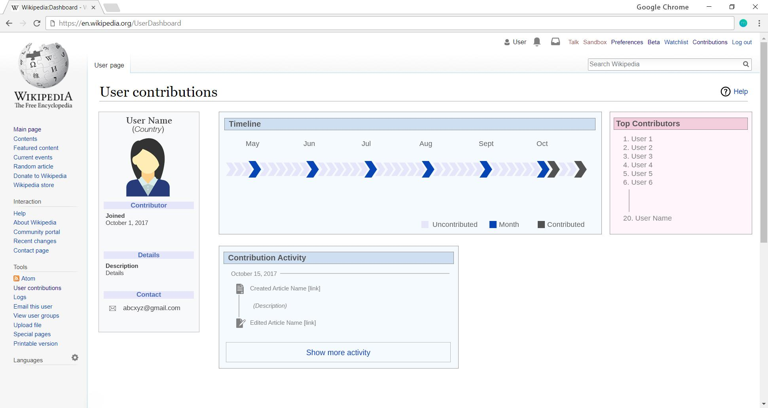
Page 2 : Achievements
-Section a : Articles Contributed
-Section b : Articles Edited

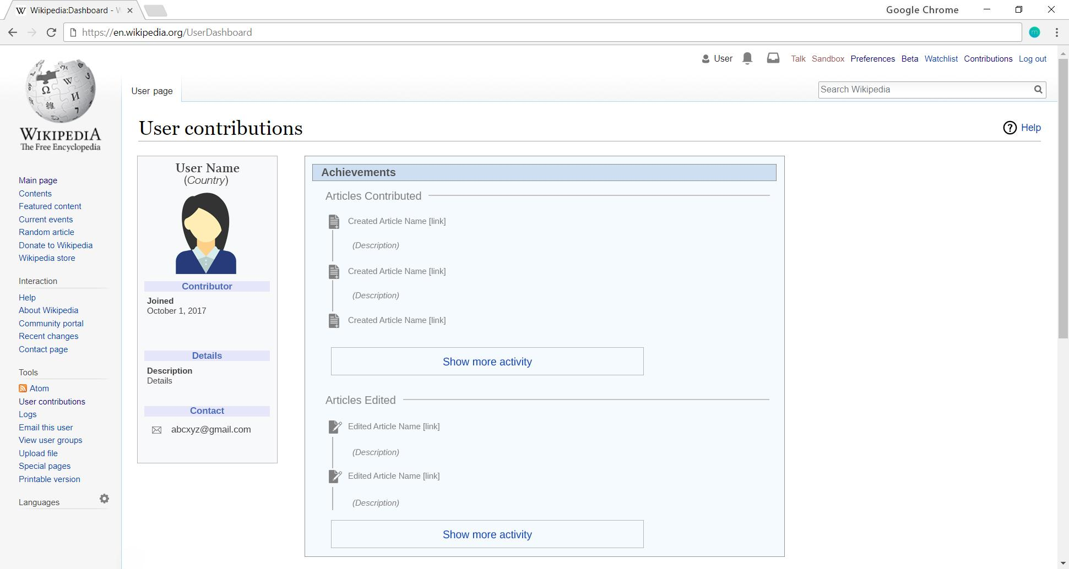
Page 3 : Contact
-Contact information like email id,mobile number(optional), wikipedia user profile link.
