2020-11-03
Georgina Burnett’s questions:

- SI created a formatterURL property with datatype 'string' (I am assuming P45 in their Wikibase?)
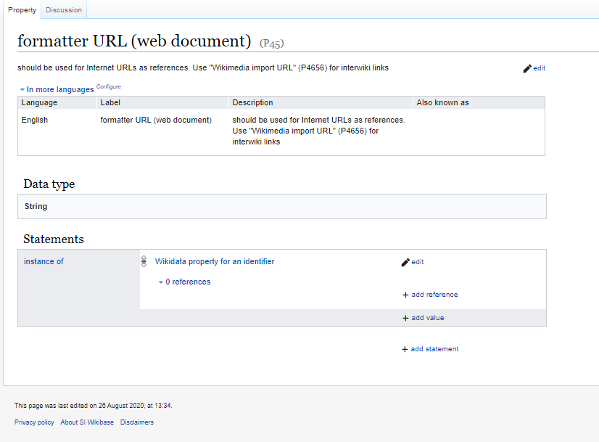

- SI created An ISNI property with datatype 'external identifier'

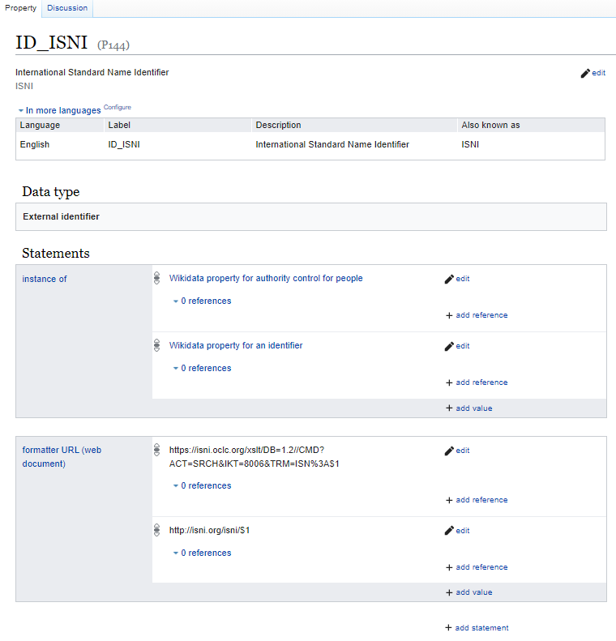
- SI added a statement to the ISNI property defining the formatterURL value
  - What was input as the formatterURL value for the ISNI property?
- SI added a statement to [some item] pointing to its ISNI identifier
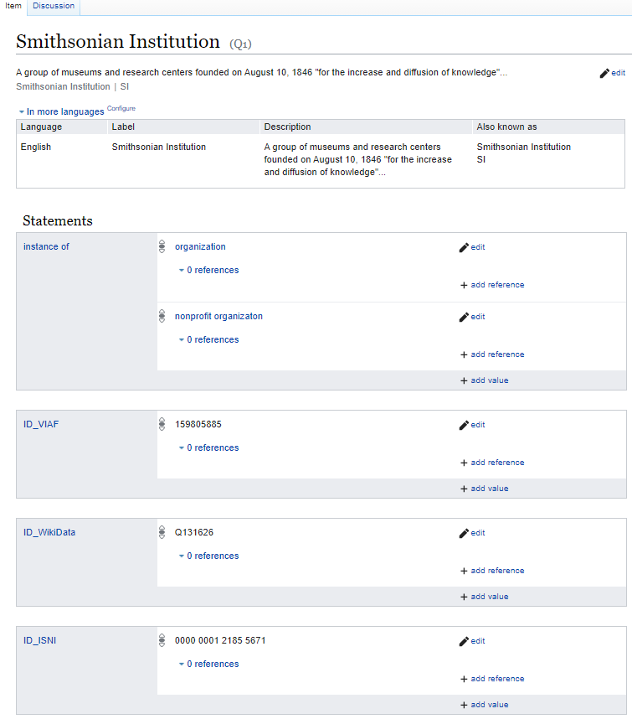
- SI edited localsettings.php to include $wgWBRepoSettings['formatterUrlProperty'] = 'P45';
Regarding the formatterUrlProperty setting, if we understand correctly, we added this to the LocalSettings.php
$wgWBRepoSettings['formatterUrlProperty'] = 'P45';
the local settings have been updated to the below:
$baseNs = 100;

# Define the namespace indexes
define( 'WB_NS_PROPERTY', $baseNs + 2 );
define( 'WB_NS_PROPERTY_TALK', $baseNs + 3 );

# Define the namespaces
$wgExtraNamespaces[WB_NS_PROPERTY] = 'Property';
$wgExtraNamespaces[WB_NS_PROPERTY_TALK] = 'Property_talk';

# Assigning the correct entity types to the namespaces
$wgWBRepoSettings['entityNamespaces']['item'] = NS_MAIN;
$wgWBRepoSettings['entityNamespaces']['property'] = WB_NS_PROPERTY;

After we added it, no one could edit
- SI ran the script mentioned in the docs: https://www.mediawiki.org/wiki/Wikibase/Installation/Advanced_configuration#Define_links_for_external_identifiers

